Analyzing the Outcome Variables as a Multivariate Response

PCA Plots

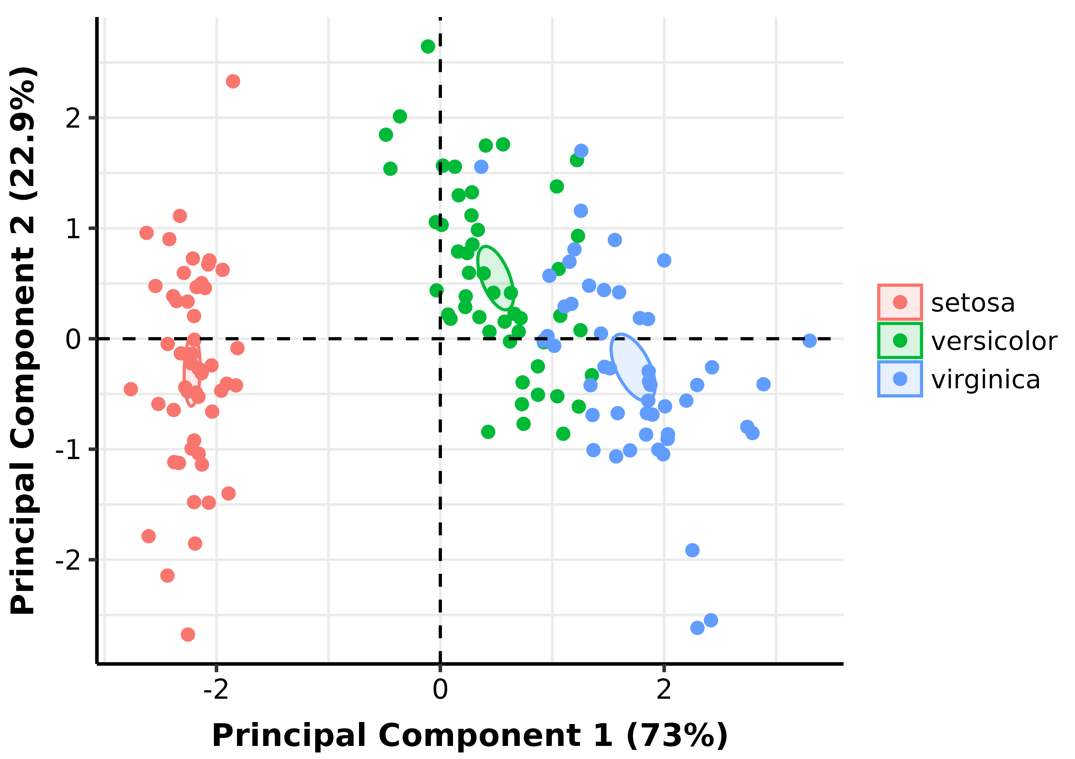
PCA Ellipse-Confidence

The 73% and 22.9% values in the axes of the figures above describe the percent variation in the data explained by the first and second principal components, respectively.

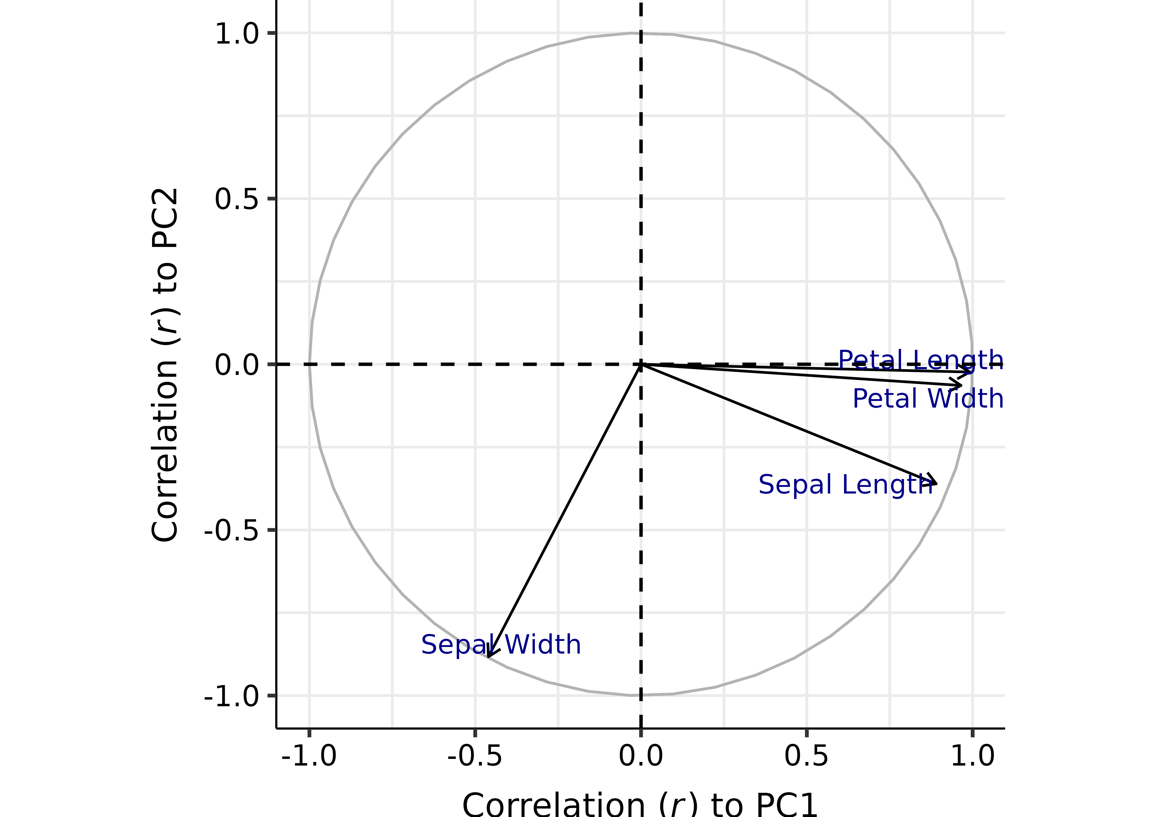
Correlation of Variables to PCs

Statistical Tables
Table 1. Pearson correlation coefficient (r) between variables and principal components
 | Sepal Length | Sepal Width | Petal Length | Petal Width | PC1 | PC2
Sepal Length | 1.0000 | -0.1176 | 0.8718 | 0.8179 | 0.8902 | -0.3608
Sepal Width | -0.1176 | 1.0000 | -0.4284 | -0.3661 | -0.4601 | -0.8827
Petal Length | 0.8718 | -0.4284 | 1.0000 | 0.9629 | 0.9916 | -0.0234
Petal Width | 0.8179 | -0.3661 | 0.9629 | 1.0000 | 0.9650 | -0.0640
PC1 | 0.8902 | -0.4601 | 0.9916 | 0.9650 | 1.0000 | -0.0000
PC2 | -0.3608 | -0.8827 | -0.0234 | -0.0640 | -0.0000 | 1.0000

Table 2. Contribution of variables to principal components
Variable | Contrib.PC1 | Eigenvec.PC1 | Contrib.PC2 | Eigenvec.PC2
Petal Length | 33.687936 | 0.5804131 | 0.05998389 | -0.02449161
Petal Width | 31.906291 | 0.5648565 | 0.44812296 | -0.06694199
Sepal Length | 27.150969 | 0.5210659 | 14.24440565 | -0.37741762
Sepal Width | 7.254804 | -0.2693474 | 85.24748749 | -0.92329566
The contribution describes how much (in %) of the PC is composed of that variable; a more precise definition is that it is the variable's Eigenvecector^2 when the sum of Eigenvecectos^2 (over all variables) is equal to 1 (100%) for each PC (this condition is implicit in PCA). The Eigenvector represents both the magnitude and direction of change of the principal component for each unit increase of the variable. This variable is in the standardized scale (z-score normalized) if scale and center arguments are set to TRUE.

Table 3. Contribution of variables to linear discriminants of Species
Variable | Contrib.LD1 | Coeff.LD1 | Contrib.LD2 | Coeff.LD2
Petal Length | 73.271102 | -3.8857950 | 32.684679717 | 1.64511887
Petal Width | 22.269408 | -2.1422387 | 56.561216217 | -2.16413593
Sepal Length | 2.288799 | 0.6867795 | 0.004810511 | -0.01995817
Sepal Width | 2.170691 | 0.6688251 | 10.749293555 | -0.94344183
LD1 and LD2 explain 99.1% and 0.9% of the separation between Species, respectively.

Tabulated values are based on Linear Discriminant Analysis (LDA). The contribution describes the percentage of the linear discriminant composed of that variable; a more exact definition is that it is the variable's coefficient of linear discriminant^2 when the sum of coefficients^2 (across variables) is normalized to 100%. The coefficient of linear discriminant describes the magnitude and direction of change in the linear discriminant score (towards a particular factor level) per unit increase of the variable. Apart from the coefficients relative signs and magnitude, they may be difficult to interpret without an associated LDA plot.

Table 4. MANOVA Results
Factor | P value
Species | 2.2e-16

Table 5. MANOVA Pairwise Comparison Results
Contrast | P value
setosa - versicolor | 1.171e-85
setosa - virginica | 2.759e-106
versicolor - virginica | 2.854e-41
P-values were generated from pairwise comparisons of levels of a factor. Comparisons were conducted using the function mvpaircomp() with the Benjamini Hochberg correction to control for a False Discovery Rate of 5%.

